INSERT ARTICLE TITLE (THREE LINES MAXIMUM)

INSERT AUTHOR’S COMPLETE NAME
Organization’s name of current affiliation (ACRONYM)
email@xxxxxx

INSERT AUTHOR’S COMPLETE NAME
Organization’s name of current affiliation (ACRONYM)
email@xxxxxx

INSERT AUTHOR’S COMPLETE NAME
Organization’s name of current affiliation (ACRONYM)
email@xxxxxx

INSERT AUTHOR’S COMPLETE NAME
Organization’s name of current affiliation (ACRONYM)
email@xxxxxx

INSERT ARTICLE TITLE (THREE LINES MAXIMUM)

1 Introduction

Insert the study introduction. From general to specific. Close the introduction with the general goal of the study. The authors must be cited in conformity with the APA. The authors must be available in the text in the following format:
According to Silva & Santos (2019) and CNPq (2018) - references must be cited like this for one or two authors.
To Francisco, Melo and Vergato (2019) – references must be cited like this for three authors.
According Prandi et al. (2019) – the references with more than three authors must include et al. after name.

Or
Xxxxxx (Silva & Santos, 2019; CNPq, 2018)
XXXXX (Francisco, Melo & Vegafo, 2020)
XXXXX (Prandi et al., 2019)

The articles must have a total of 15 pages maximum (considering all the topics of the study and its bibliographic references).
The articles must be formatted according to the presented template. Arial letter (respecting sizes and colors, being the internal text [in black] with size 11). The spaces must be 0 (zero) before and after paragraphs and 1,5 between lines. The images must be cited as: Figure 1, Figure 2, and so on. Figure 1 illustrates how the figures should be inserted in the text. It should be noted that the images must be legible (in high quality) in the language of the article.

Figure 1 – Logo International Conference on Creative Territories for Sustainable Development. Source: International Conference on Creative Territories for Sustainable Development (2021).

The frames should be denominated as Frame 1, Frame 2 and so on. Table 1 below illustrates an example of a table.

Frame 1 – Example of how to make a frame for the International Conference on Creative Territories for Sustainable Development.
 | Information 1 | Information 2
Information 1 | Information x | Information z
Information 2 | Information y | Information w
Source: Elaborated by the authors.

The tables must be called Table 1, Table 2. The Table 1 below illustrates an example of a table to be used in the International Conference on Creative Territories for Sustainable Development.

Table 1 – Example of how to make a table for the International Conference on Creative Territories for Sustainable Development.
 | Information 1 | Information 2
Information 1 | Information x | Information z
Information 2 | Information y | Information w
Information 3 | ... | ...
Source: Elaborated by the authors.

Observe the colors of the magazine as illustrated in Figure 2.

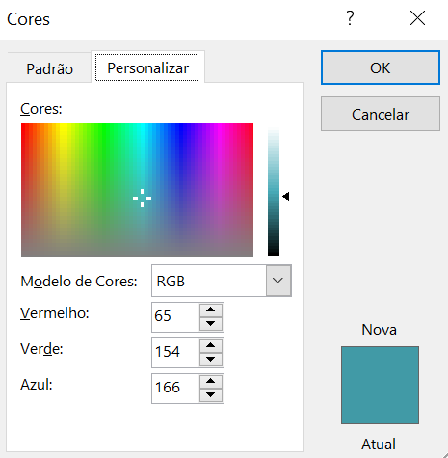
Figure 2 – Colors of the International Conference on Creative Territories for Sustainable Development for titles, authors’ names, frames and tables. Source: International Conference on Creative Territories for Sustainable (2021).

It should be noted that the header and footer will be changed later by the editorial team. However, it is worth remembering that authors must strictly follow the proposed template.

2 Methodological Proceedings

Insert the study procedures that must deal with the characterization of the research, its stages, focus of study, instruments for data collection and analysis performed.

3 Results and Discussion

Insert the results found from the research and discuss these with the existing literature. It is recommended to use a total of 85% of international references from scientific studies.

3.1 Subtitles

4 Conclusions

Insert the conclusions of the study in order to answer the proposed objective.

5 Bibliographic References

Examples:

Associação Brasileira de Normas Técnicas. (2001). NBR ISO/IEC 9126-1: Engenharia de software - qualidade de produto parte 1: modelo de qualidade. Rio de Janeiro: Associação Brasileira de Normas Técnicas.

CNPq. (2018). Sobre a plataforma Lattes. 2018. Disponível em: <http://lattes.cnpq.br/>. Acesso em: 06 de jun.

Corrêa, BN, Souza, RK & Teixeira, CS. (2020). Inovação frugal: requisitos para o desenvolvimento. São Paulo: Perse Editora.

Matos, GP, & Teixeira, CS. (2020). Características, distinções e semelhanças entre sistemas de inovação e ecossistemas de inovação. E&G Economia e Gestão, 20(56): Belo Horizonte, v. 20, n. 56, 45-52.

Pique, JM, Miralles, F, Teixeira, CS, Gaspar, JV & Branco, JR. (2019). Application of the triple helix model in the revitalization of cities: the case of Brazil. Int. J. Knowledge-Based Development, 10(1): 43-74.

Acknowledges

Authors can use this topic to thank funding agencies or other sponsors, if necessary.

